

**Computer Organization and Architecture (CSE112)**

Major Task : MIPS Processor design using VHDL

**Submitted to:**

Dr Tamer Mostafa

Dr Kareem Emara

Eng. Ahmed Fawzi

Eng. Mohamed Atef

**Submitted by:**

|  |  |
| --- | --- |
| Rafik Tamer Magdy | 20P1046 |
| Brwana Ahmed Mourad | 20P1346 |
| Mina Morgan Mounir | 20P1943 |
| Mark Bassem Heshmat | 21P0363 |
| Ahmed Wael Ibrahim | 20P3343 |

Table of Contents

Objective 3

Main Objective 3

Given Requirements 3

Implementation 3

Solution Description 3

RTL Schematic View 4

Simulation Waveform 4

Register Component Code 5

Multiplexor Component Code 6

Decoder Component Code 8

Package Declaration Code 10

Main Module (Register File) Code 12

Module Test Bench Code 14

Phase (2) – Processor Design

# Objective

## Main Objective

Design a simple MIPS CPU using VHDL. The proposed CPU should be able to perform certain instructions:

* **R-type:** AND, OR, ADD, SUB, SLT, NOR
* **I-type:** LW, SW, BEQ, BNE
* **Jump instructions**

## Given Requirements

**MainModule** Entity should look as follows:

* START: IN STD_LOGIC;
* CLK: IN STD_LOGIC;
* RegFileOut1: OUT STD_LOGIC_VECTOR(31 downto 0);
* RegFileOut2: OUT STD_LOGIC_VECTOR(31 downto 0);
* ALUOut: OUT STD_LOGIC_VECTOR(31 downto 0);
* PCOut: OUT STD_LOGIC_VECTOR(31 downto 0);
* DataMemOut: OUT STD_LOGIC_VECTOR(31 downto 0);

**Test Case:**

Assembly program that calculates the first twelve Fibonacci numbers and store them in array at the beginning of the Data Memory.

After the program finishes, you should see the following sequence in $s0: 1, 1, 2, 3, 5, 8, 13, 21, 34, 55, 89, 144, 0, -1

# Implementation

## Solution Description

Solution idea is to gather the following components and connect them using the single-cycle processor design conventions to implement each instruction type separately. All instructions are then connected through multiplexors to ensure generalizations in the processor design.

*Needed Components:*

* **32-Bit ALU:**
  + Performs all Arithmetic/Logical operations used in the processor.
  + In this implementation we used another implementation of the ALU with added SLT capability.
* **32-bit Register File:** Holds the instruction operands.
* **Instruction Memory:** Holds the program instructions sequentially to be executed by other components.
* **Data Memory**
* **Control Unit:**
  + Produce Control and Enable signals to all components of the processor.
  + Selects needed components for instruction being carried out.
  + Selects operations of the ALU.
* **ALU Control Unit:** Receives the operation code from the control unit and produces ALU Opcodes to the ALUs.
* **Program Counter:**
  + 32-bit Register.
  + Holds address of the current instruction being executed in the instruction memory.
  + Can be loaded with different address to navigate through the instruction memory and execute the instructions in any desired order.
  + Essential for branch and jump instructions.
* **Sign Extender:** Used to extend the 16-bit immediate bits in an instruction into 32-bit form to facilitate processing by the ALU.
* **2×1 Multiplexor:** Used to connect all the instruction circuits to generalize the processor instruction execution.

## Fetching instructions

1. The instructions are loaded into the **instruction memory** before operating the processor by filling each 32-bit word with complete instruction codes.
2. **Program Counter** has output with the address value of instruction which is passed to the *address* pin of the **Instruction Memory**.
3. **Instruction Memory** address pin selects the needed instruction register and transfers the fetched instruction code to the *instruction* output pin.
4. The instruction code is transmitted to the rest of the processor through a 32-bit bus. The bus bits is divided according to the instruction types.
5. A branch is taken for the output pin of the **Program Counter** that is passed into an **Adder ALU** to add the current instruction address to 4. The result is the address of the next instruction in memory since the processor uses byte-addressing methodology.
6. ALU adder is created by using an ALU module and fixing the opcode to “0010” which is the ADD opcode.
7. The input pin of the Program Counter is connected to an external circuitry that will be further explained later in this section that selects the next instruction address according to the instruction used: (jump, branch, or R-type).

## R-type instructions

The 32-bit instruction bus is divided in the R-type as follows:

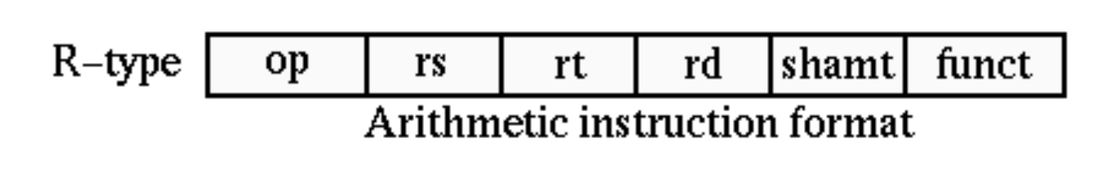

The instruction operands should be passed to the register file to load the needed registers so the following pins from the instruction bus are connected like so:

* **(21-25) Bits:** “rs” the selection bits for the first register to be read from the register file.
* **(16-20) Bits:** “rt” the selection bits for the second register to be read from the register file.
* “rd – destination register bits” the selection bits for the register to be written into the register file is connected to 2×1 MUX (WriteRegMUX) to select the proper address.
* **WriteRegMux** has 2 inputs of **(16-20) & (11-15)** bits from the instruction bus to select between **“rt”** & **“rd”** to connect the Load/Store operations to the R-type operations and the output is supplied to the **write_data** bits of the register file.
* Selection signal of the **WriteRegMux** comes from the **RegDst** control signal from the main **control unit**.
* From the instruction code execution algorithm studied from the lectures, 2 values should be fetched from the **register file** and loaded to the **ALU** to be perform the Arithmetic operation needed.
* An ALU module is used with the following configurations:
  + 1 Input pin is connected to **data1** output of the register file.
  + The second input pin is connected to the output of a 2×1 MUX **(ALU_MUX)**.
  + The **AlUOp** code is obtained from the **ALU Control Unit**.
  + The output pin is connected to another MUX input that selects between the ALU result and the data fetched from the **Data Memory** and the output of this MUX is connected to the **write_data** pins of the register file.

In summary, the data is fetched from the instruction memory, the signals are divided and supplied to their corresponding pins on the register file. 2 registers are read from the register file and are supplied to the ALU module. The result of the ALU operation is returned back to be written into the desired register in the register file.

## I-type instructions

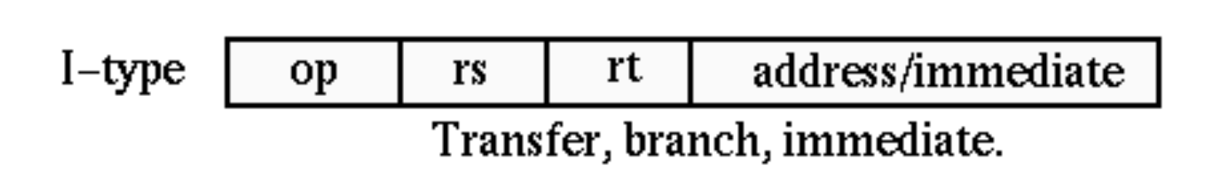

The instruction operands “rs - rt” should be passed to the corresponding register file pins and the offset/immediate value should be passed to the ALU to be added with the data1 read value to be summed together.

Register File and ALU components are of the same configurations as mentioned in the last section.

Data Memory component is added and used as follows:

* The result of the summation of the data read (rs) from the **register file** and the immediate values are supplied to the address input pins of the **Data Memory**.
* The output data pins from the **Data Memory** are then passed to the **WriteRegMUX** input pin at the **write_data** pins of the register file to select from the data retrieved from the **Data Memory** and the result of ALU operation for R-type instructions.

## Jump instructions

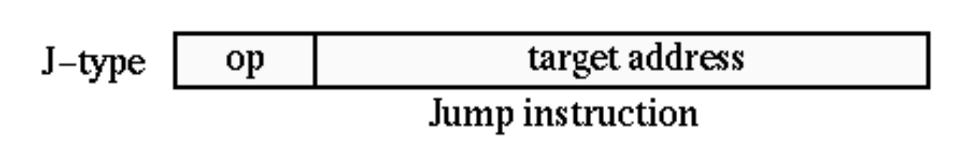

1. The last 26 bits of the instruction code are retrieved from the instruction bus in a signal called **targetAddress**.
2. “00” are appended at the beginning of the targetAddress binary code and becomes a 28-bit code.
3. The last 4 bits from the **Program Counter** are appended at the end of the **targetAddress** binary code to get a 32-bit target address binary code which is supposed to be provided to the **Program Counter** input pin.